1. **Create an empty file that has 0 bytes**

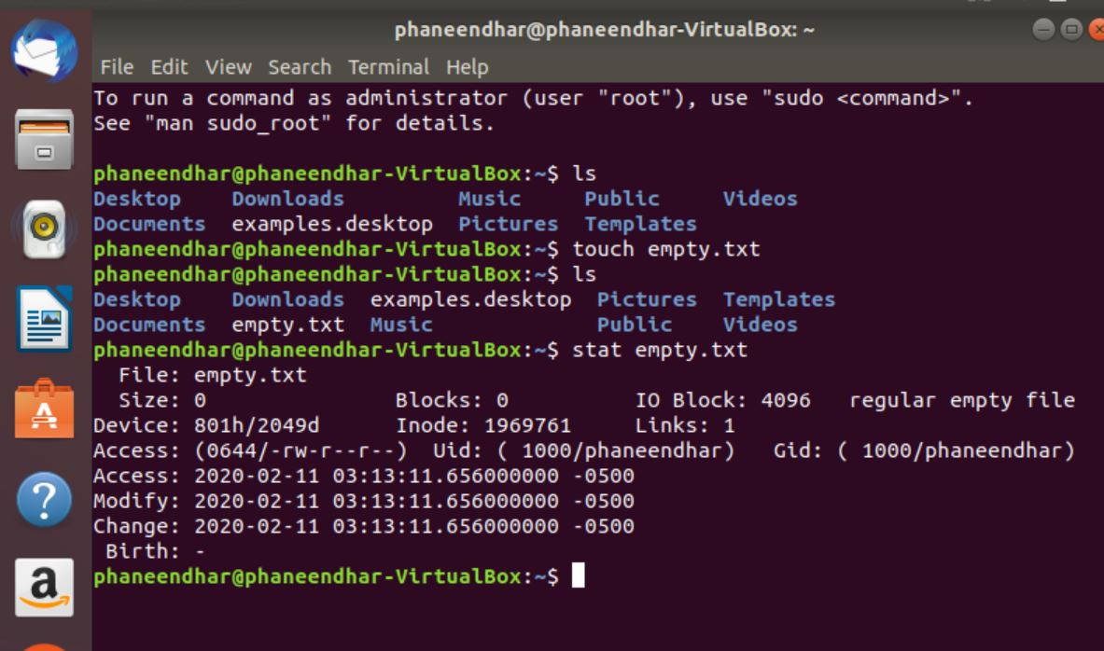

1. **Create a directory with the Name “Day-1Assignments”**

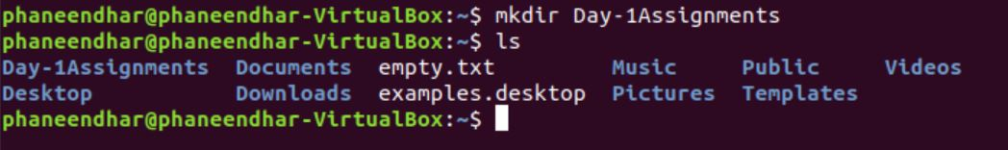

1. **In the directory that you create, create 5 files like 1.txt, 2.txt, etc and have a word of that number as the file name.**

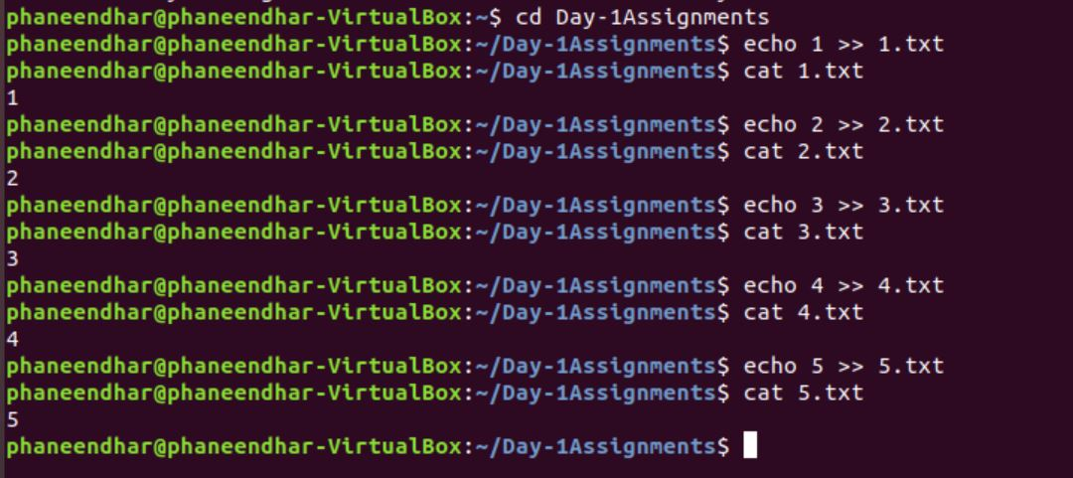

1. **List out all the files in the current directory**

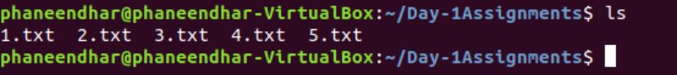

1. **There are two special directories for each directory. Find out using the ls command.**



1. **Using the echo command, create a file and keep the contents of echo into the file.**

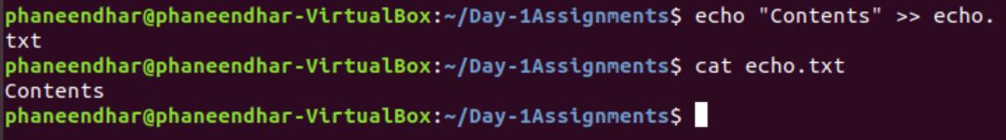

1. **Now append Six to the file 5.txt (This was created earlier)**

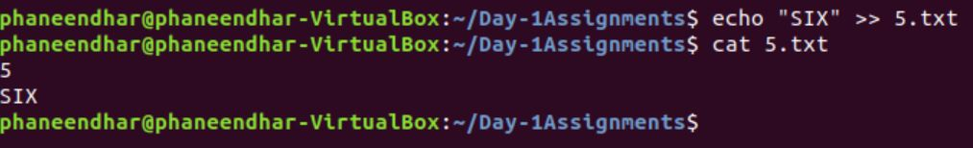

1. **Create a file with the name 6.txt that contains all the contents of the files that you have created earlier.**

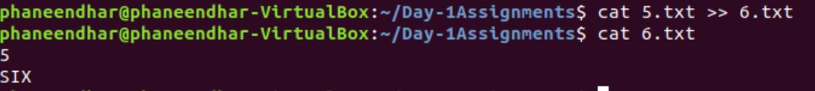

1. **Search for a file that has a name 5**

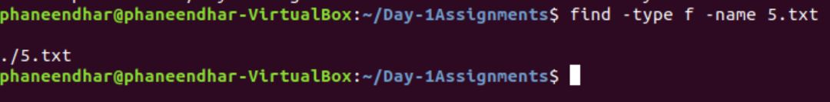

1. **Create multiple directories and keep moving files from one directory to another directory.**

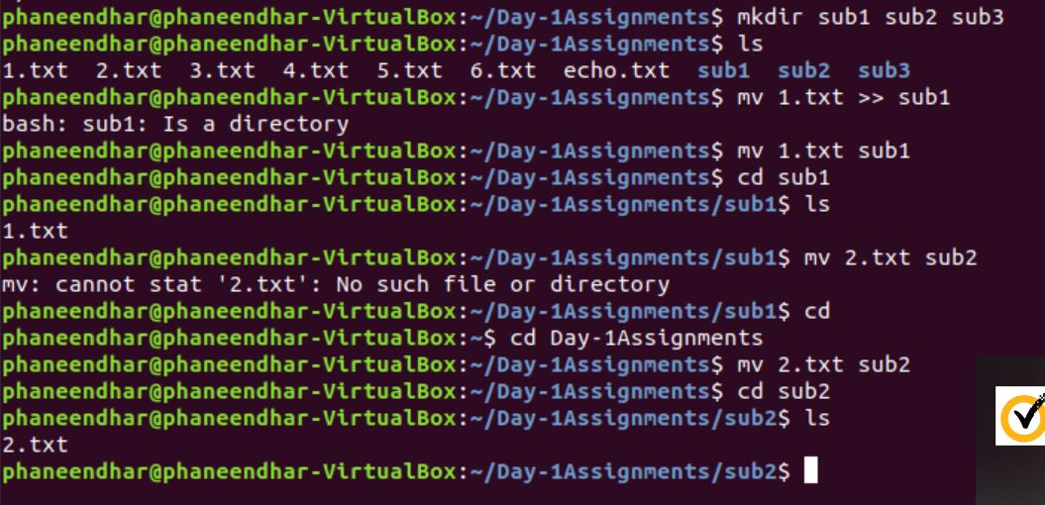

1. **Be in the parent directory, Search for a file that has a name 5**

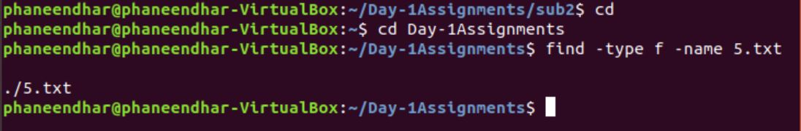

1. **Copy the files from one directory into its parent directory.**

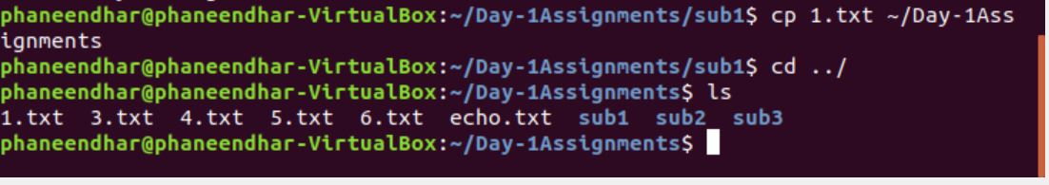

1. **Remove all the subdirectories from the current directory using a single command.**

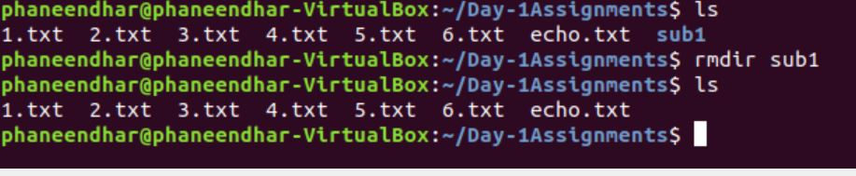

1. **Write the output of the ls command to a file.**

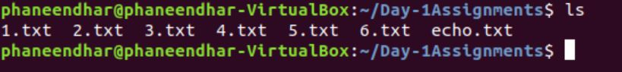

1. **List the contents of the etc directory**

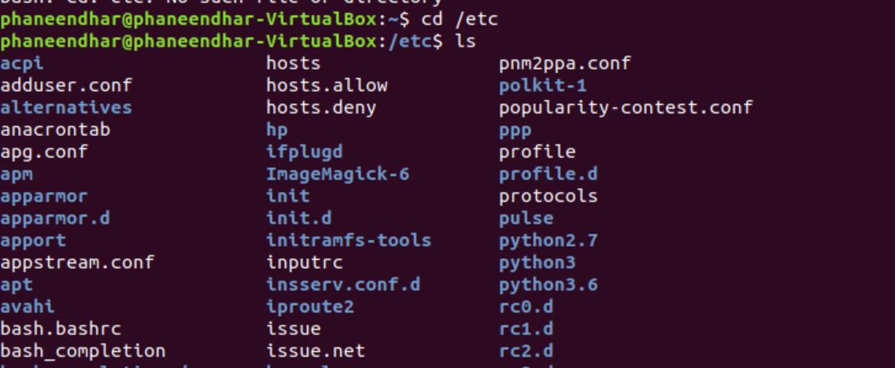

1. **Display the contents of the passwd file from /etc/passwd**

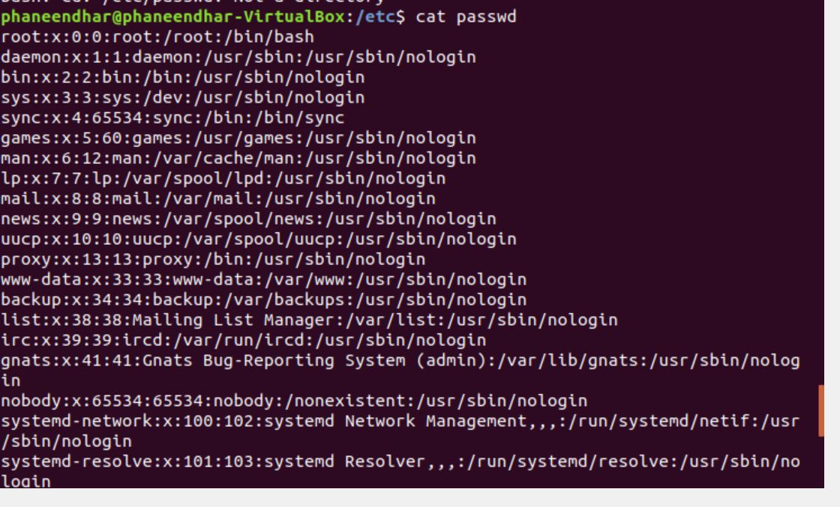

1. **Print only the line with “Whoops” from the above file**

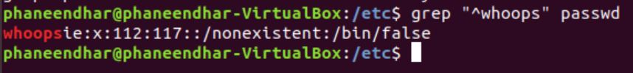

1. **Keep typing bash for 3 - 4 times and observe the difference in the output**

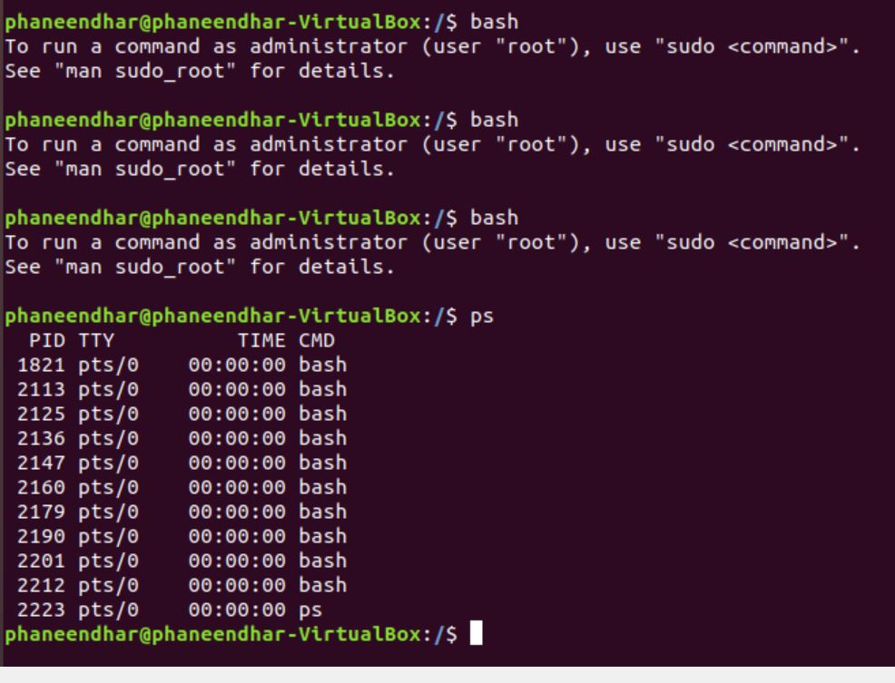

1. **Now try to enter the ps command and observe the output of this command**



1. **Now try to enter the exit command and observe the output of the ps command**

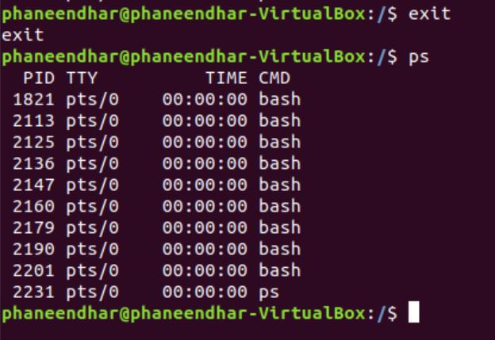

1. **Continue, use the kill command with parameters and with a process id, check for the output.**

